**MINAHIL QADIR**

**BSAI-3A(047)**

**TASK 1:**

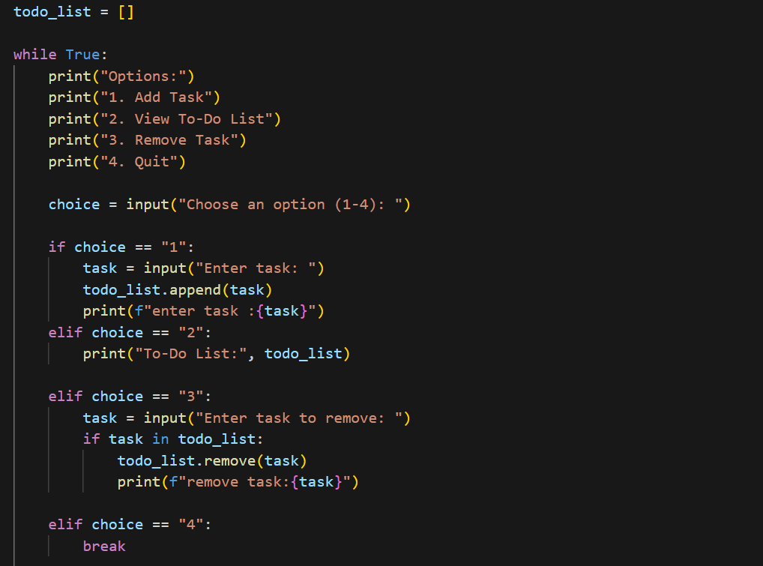

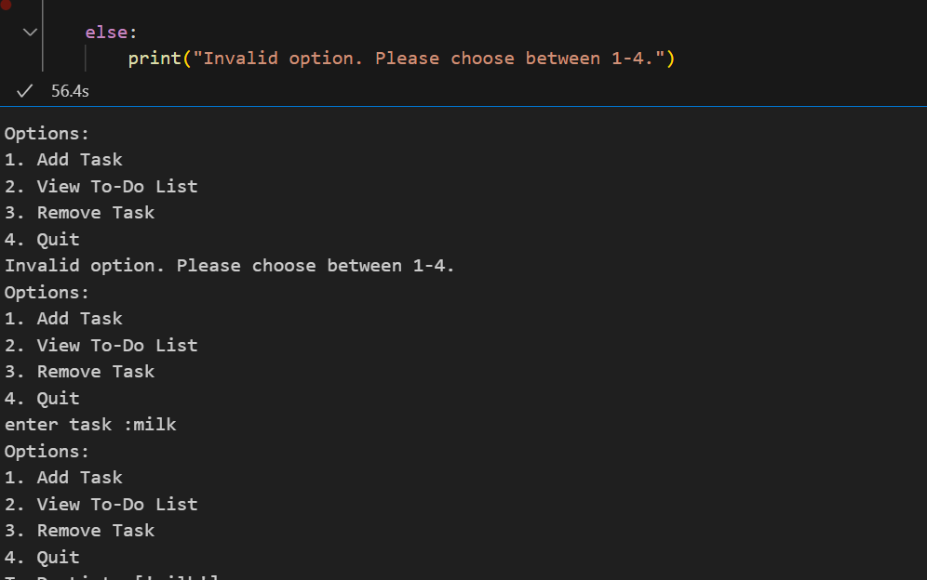

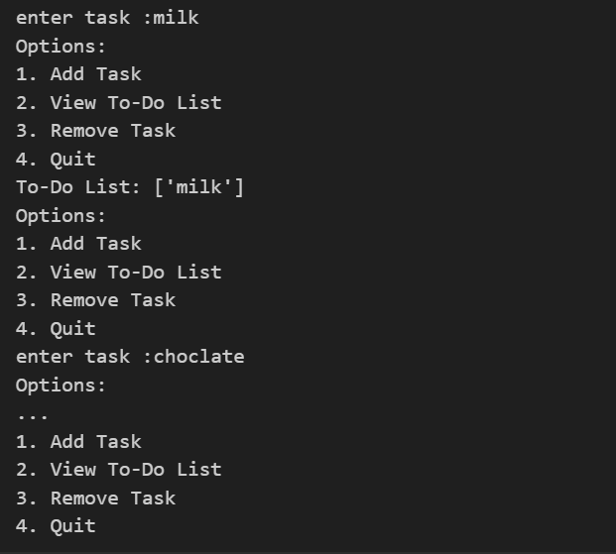

This is a simple To-Do List program that lets the user add, view, and remove tasks using a menu system.

It uses an infinite loop (while True) to keep showing options until the user chooses to quit.

Menu options:

1: Add a task → User enters a task, which is added to todo_list.

2: View tasks → Displays all tasks in todo_list.

3: Remove a task → User enters a task, and if it exists, it gets removed.

4: Exit the program → The loop breaks, and the program ends.

Handles invalid inputs by prompting the user to choose a valid option (1-4)